Equal Experts

Detailed Automation Framework

Hotel Booking Form

This copy printed on: August 22, 2010

Document Last Modification date: August 6, 2018

Version: 0.1

Status: Draft version

Revision: 1

Document Owner: SanikaSanjay Consultancy Ltd

Document Author: Sanjay Adav

Document Reviewer:

Document History

This Document provides details information on the testing information of Hotel Booking form provided by Equal Experts.

Revision History

|  |  |  |  |
| --- | --- | --- | --- |
| **Version Number** | **Revision Date** | **Summary of Changes** | **Changed by** |
| V 0.1 | 06/08/2018 | Initial Version |  |

Reviewer

|  |  |  |  |
| --- | --- | --- | --- |
| **Name** | **Position/ Department** | **Version** | **Review Date** |
|  |  |  |  |
|  |  |  |  |
|  |  |  |  |

Approvals

|  |  |  |  |
| --- | --- | --- | --- |
| **Name** | **Position/ Department** | **Version** | **Approve Date** |
|  |  |  |  |
|  |  |  |  |

Distribution

This document is available to:

Entire Project

Restricted to the following team members

|  |  |
| --- | --- |
| **Name** | **Title** |
|  |  |
|  |  |

Contents

Introduction

Background

This document detailed the Test Automation Framework designed to Automate Equal Expert – Hotel Booking Form.

Framework on High level

The framework targeted is TestNG with POM Design pattern implemented by Page Factory.

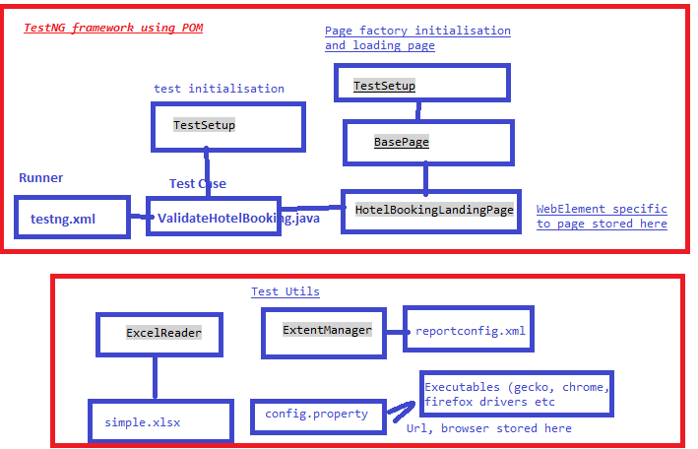

Document Audience

| **Role** | **Name** | **Email/ Telephone** | **Organization** |
| --- | --- | --- | --- |
| Product Owner |  |  |  |
| Project Manager |  |  |  |
| PMO |  |  |  |
| QA |  |  |  |
| Functional Team Lead |  |  |  |
| BA |  |  |  |
| Business Unit |  |  |  |
| Development Team Lead |  |  |  |
| Infrastructure Team Lead |  |  |  |
| Infrastructure Team |  |  |  |
| Test Lead |  |  |  |
| Test Team |  |  |  |
| Deployment Team Lead |  |  |  |
| Deployment Team |  |  |  |
|  |  |  |  |
|  |  |  |  |

* Remove the role which may not include in your project charter. * If document change version and the stakeholder name is changed, should modify the name as well..

Detailed information of each modules

This document is based on and refers to the following documents:

Table 1: Test Resources (src/test/reources)

|  |  |  |
| --- | --- | --- |
| **Class / folder** | **Functionality automated** | **Comments** |
| Archived Reports | All previous run reports will be archived and saved here | Implementation pending |
| Executables | All driver specific to testing saved here *e.g. Gecko driver, Chrome driver, IE server driver etc |  |
| ExpentConfig | Config details for Extent reports saved here e.g. report theme, title, headline etc |  |
| Lib | Any external which cannot be downloaded using POM.XML can be saved here |  |
| Property File | Config properties like url, browser specific to particular test environment can be saved here |  |
| Runner | This is the starting point of automation frame. Define the list of tests, cases here in sequence/parallel. | Not tested test cases in parallel |
| Test Data | The data input to the test cases are saved here | Used Apache POI to read excel file |

Table 2: Test cases (src/test/java)

|  |  |  |
| --- | --- | --- |
| **Class / folder** | **Functionality automated** | **Comments** |
| ValidateHotelBooking.java | This contains the list of test cases with priority. As I have used POM design patter each test cases called page specific object and return the page based on the outcome pass/fail  This class extends TestSetup (more details follows) |  |

Table 3: Test Dependencies (POM.xml)

|  |  |  |
| --- | --- | --- |
| **Class / folder** | **Functionality automated** | **Comments** |
| POM.XML | The test automation artifacts like Group Id, Name, descript saved along with the list of Dependencies are mentioned in it |  |

Table 4: Test cases (src/main/java)

|  |  |  |
| --- | --- | --- |
| **Class / folder** | **Functionality automated** | **Comments** |
| io.ee.hbf.CustomListeners/ CustomListners | Used for reporting during automation script run | Implementation pending |
| io.ee.hbf.PageActions | All page specific actions like method can be saved here. |  |
| io.ee.hbf.PageObjects | All page specific elements are saved here so that it can be maintained easily at one place |  |
| io.ee.hbf.Rough | Created to test any code before placing into specific module. | For rough work only |
| io.ee.hbf.Setup | All setup activities like initialization of excel reader, extent report, webdriver initialization done here.  Used testing events like BeforeSuite, AfterSuite, BeforeClass |  |
| io.ee.hbf.TestUtils | All test utilities like Excel reader, Extent Manager all saved here. These utilities can be used in other projects |  |

Definition and Acronyms

This section provides information regarding the Acronyms and terminology specifically used in this document.

Table 2: Definitions and Acronyms

| **Acronym** | **Definition** |
| --- | --- |
| HB | Hotel Booking |
|  |  |
|  |  |
|  |  |
|  |  |
|  |  |

Testable Items

Functionality tested

The automation tested the below scenarios using TestNG runnerL

1. hotelBookingE2ESaveAndDelete – End 2 End testing
   1. Create booking with specific use details
   2. Delete the recently created booking
2. doHotelBookingwithValidData

Create new booking

1. deleteHotelBooking

Delete newsly created booking

Out of Scope

### Performance testing

2.2.2. Negative testing

Testing Exclusions

### Currently the below activities are excluded in the test framework due to time constraints

* Implementation of data retrieval from excel read. Instead I have hard-coded data in DataProvider
* Implementation of IEServerDriver to test the Hotel Booking in IE browser
* Implementation of Extent report which will take time for implementation. Still we can see the report using TestNG report generated in test-output folder
* Report Archival
* Screenshot in case of test failure. Once done it can be linked to Extent report

Detailed Test Approach

Naming Conventions for Function Groups and Functions

Test Case Design

Test Scheduling

Test Environments

Infrastructure

Test Data preparation

Test Schedule

Appendix A - System Schematic/s